2-3 Activity: Clean It, Code It, Frame It
Explain how transforming raw data into table format supports analysis and decision making in your field of interest: In the field of business data analytics, the process of data wrangling is essential since if the underlying information is not correct then the conclusions reached will be incorrect (i.e. garbage in, garbage out). If the data is not cleaned prior to analysis outliers and the duplicates present in the data will have a negative impact on the accuracy of the conclusions generated, and if those conclusions are not presented in an easy to understand or use format the information may not be properly understood by the intended audience. In business and in this practical example, the initial data can be assessed for anomalous data that can represent potential outliers, like the frequent entry reporting entry with a maximum temperature of 5505.0 degrees, please see Figure 1. If included, these outliers would significantly distort the analysis. The data size can also be analyzed to determine if potential duplicates are present; in this exercise the data collection period is from 1/1/18-12/31/18, with daily collections but there are 765 rows present in the file, please see Figure 2, indicating that there are duplicates present in the data. Finally, the data output can be compared with industry benchmarks to assess the reasonableness of the output. In this example, the data available for Boonton 1 SE, New Jersey reporting the average annual snowfall rate of 27 inches (Climate and Average Weather Year Round in Boonton, New Jersey, n.d.), the annual precipitation rate of 49 inches (NJ Monthly/Annual Normals (1991-2020), n.d.), and annual maximum and minimum temperature of 92°F. and 7°F (Climate and Average Weather Year Round in Boonton, n.d.) was compared with the analysis output to assess reasonableness, please see Figures 3 and 4. Thus, the process of data wrangling improves the accuracy of the underlying data used and is therefore essential for the creation of useful information for the intended audience.
References

(n.d.). Retrieved from NJ Monthly/Annual Normals (1991-2020): https://climate.rutgers.edu/stateclim_v1/norms/monthly/pcpn.html
Climate and Average Weather Year Round in Boonton. (n.d.). Retrieved from Weather Spark: https://weatherspark.com/y/23629/Average-Weather-in-Boonton-New-Jersey-United-States-Year-Round
Climate and Average Weather Year Round in Boonton, New Jersey. (n.d.). Retrieved from myPerfectWeather: https://myperfectweather.com/api/cityinfo/34027Boo/degF/Average-Weather-in-Boonton-New-Jersey-United-States-Year-Round

Figures
Figure 1: Anomalous Data
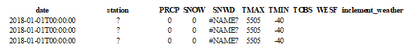
Figure 2: Jupyter Notebook Outputs: Raw Data Shape
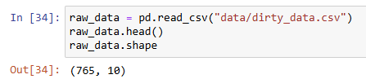

Figure 3: Snowfall Column Analysis
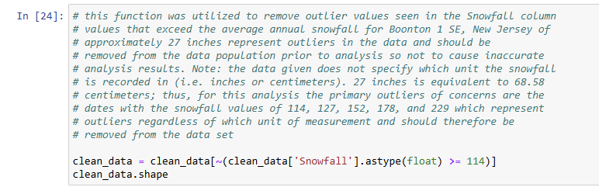

Figure 4: Precipitation, MaxTempF, and MinTempF Column Analysis
